**Topic: SQL**

**STEP1:** -- Create database and then Create table ;

CREATE TABLE class1 (

Enrollment_No INTEGER PRIMARY KEY,

student_name varchar(20) NOT NULL,

section varchar(5) NOT NULL,

subject_id int(5),

marks int(5)

);

**NOTE :** Enrollment _No is PRIMARY KEY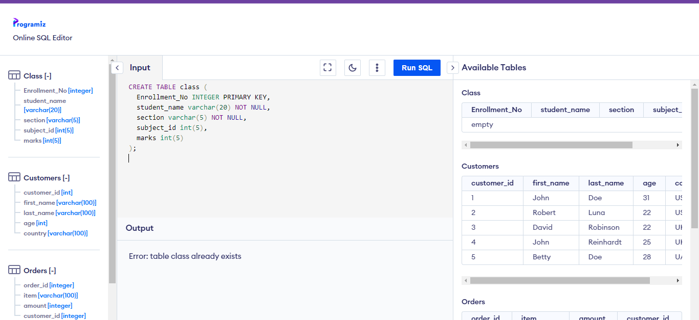

**STEP 2:** -- insert into the value of created table class1;

INSERT INTO Class1 VALUES (1, 'TIM', 'A',1,70);

INSERT INTO Class1 VALUES (2, 'JIM', 'A',2,75);

INSERT INTO Class1 VALUES (3, 'KIM', 'B',3,65),

(4, 'TOM', 'B',4,77),

(5, 'JOHN', 'C',5,60)

,(6, 'JOE', 'C',1,82)

,(7, 'JAMES', 'B',2,76),

(8, 'HENRY', 'C',5,68),

(9, 'MATT', 'B',3,71),

(10, 'PAUL', 'A',4,79);

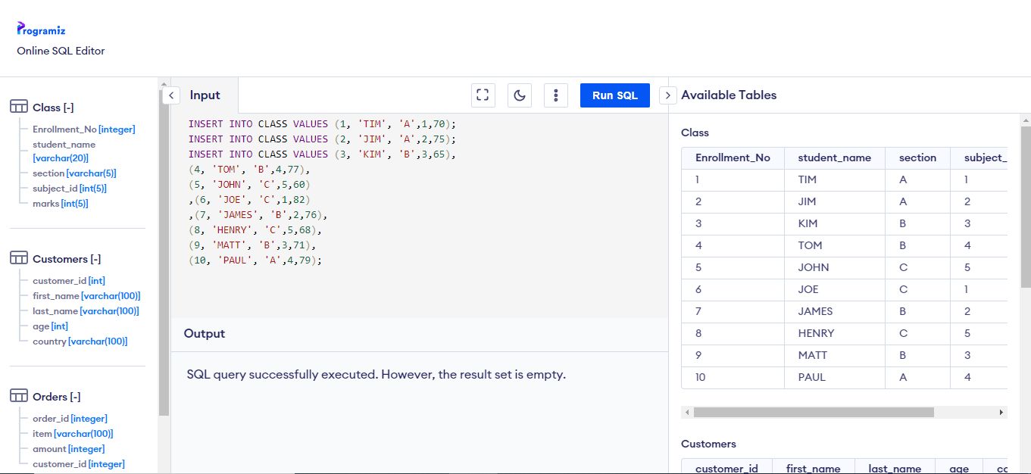

**STEP 3:**

-- fetch Query

SELECT section,COUNT( Enrollment_No) as NO_of_Candidate

FROM class1

where marks>=75

group by section;

And Then Display The Output

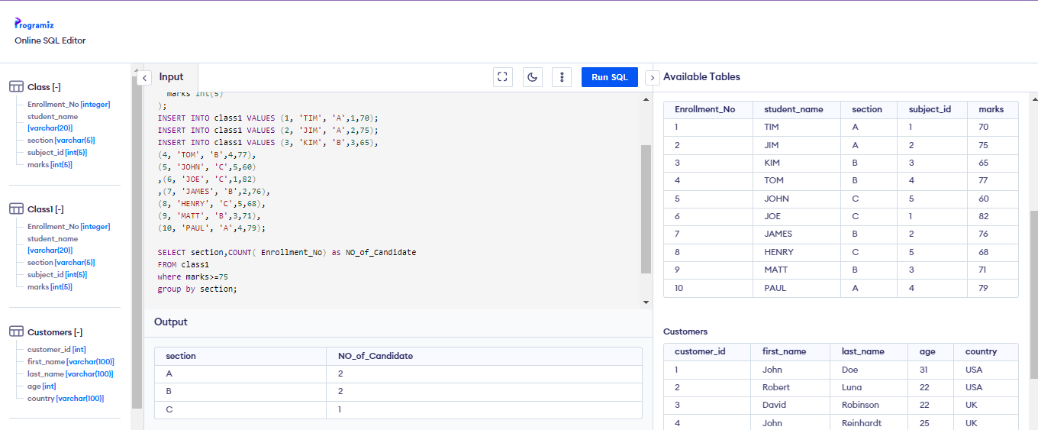

**Topic: Tableau**

First Create A Csv File On Excel And Save Local Disk

Import The Data From Local Disk To Tableau Worksheet And Use Worksheet

**STEP1:**

Need Column Drag & Drop ( ID & Empname ) Into The Rows And Same Time Salary Drag To Marks Label.

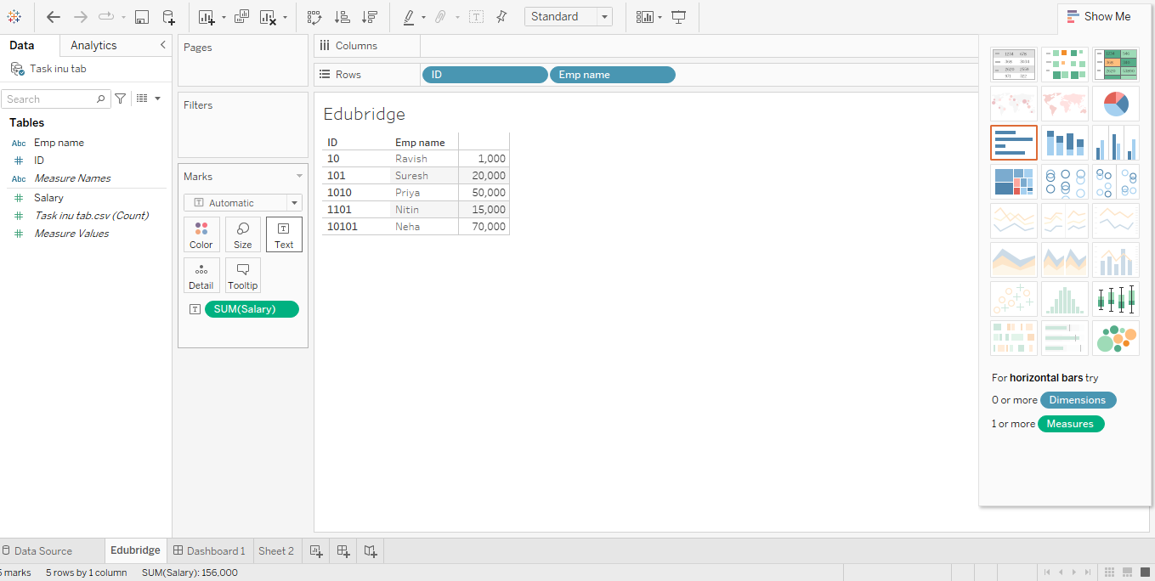

**STEP 2:**

Then Near Filter By Click Icon Show The Options Here And Create Calculated Field.. Click

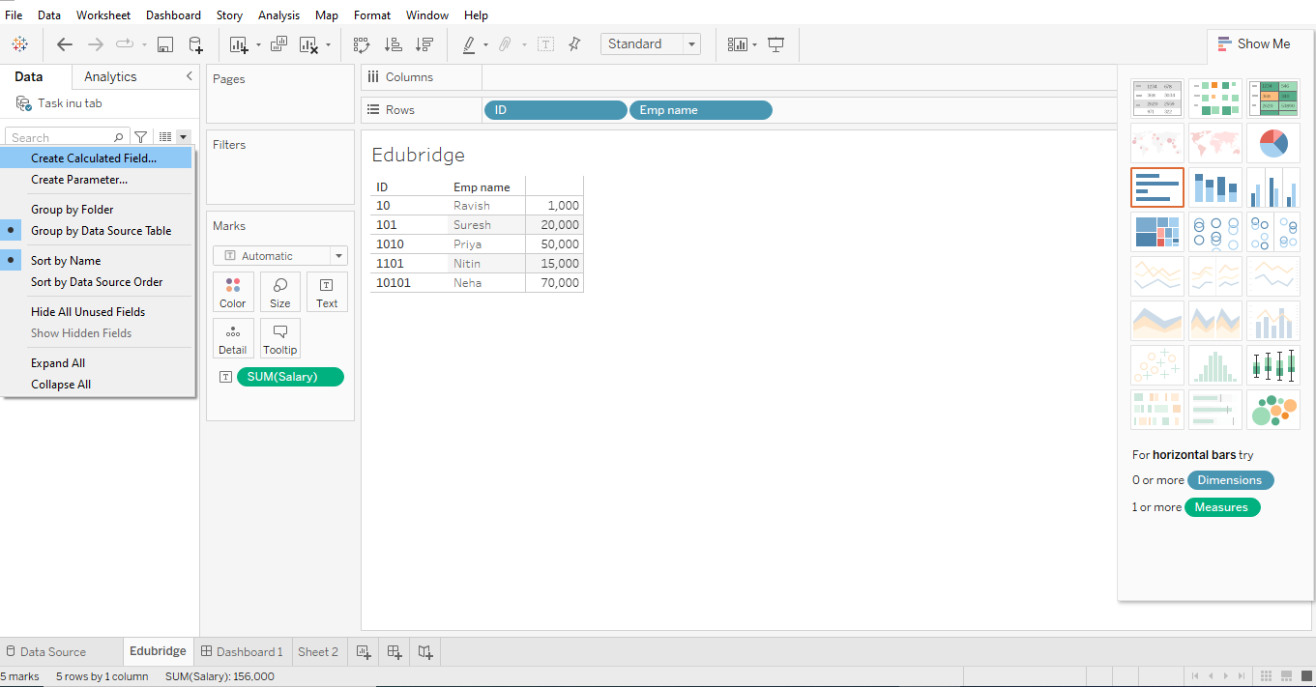

**STEP 3:**

The Dialogue Box Will Be Open Put Column Name Empid New And, Then Text Box Write The Formulas

LEFT(“0000000”,(7-LEN(STR([ID])))) + STR([ID])

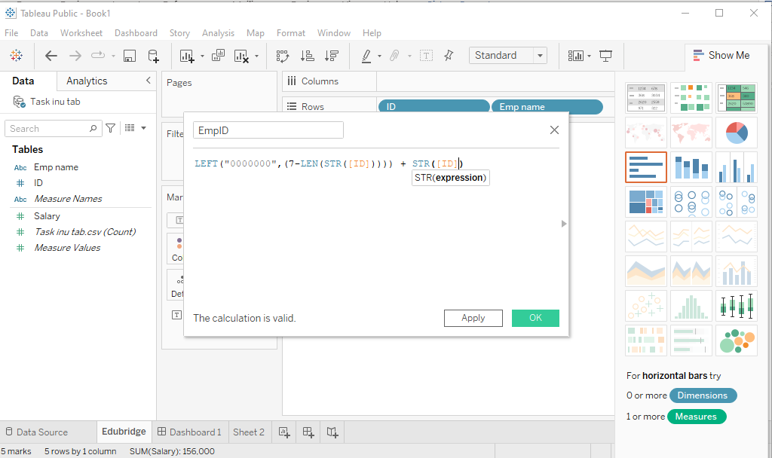

**STEP 4:**

New Measure Name Will Be Created And Just Drag And Drop The Rows Show The Table Crete A Seven Digit EMP ID { .Format (0000000)}

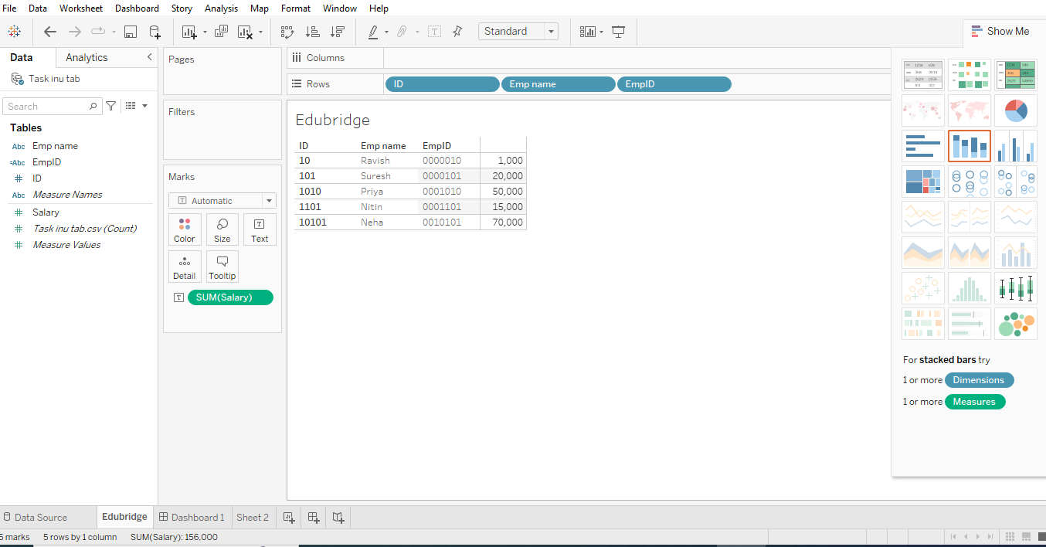

**Topic: Excel**

**STEP 1:**

Create the Excel file include data Customer name.

And then select the entries cells, open home Go to conditional formatting and then choose Highlight cells rules click and choose duplicate values (go with click the option or use shotcut key your options ).

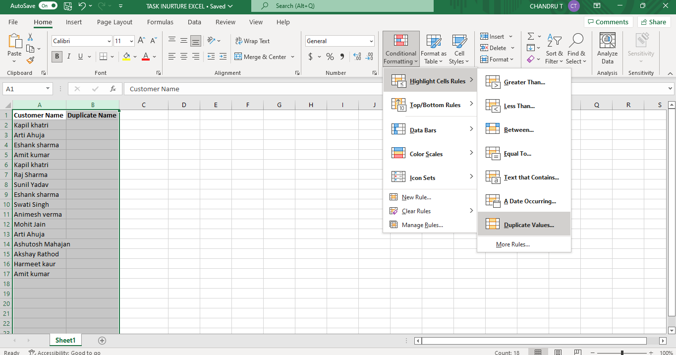

**STEP 2:**

choose duplicate value with highlights the red colour (choose duplicate values or unique values options)

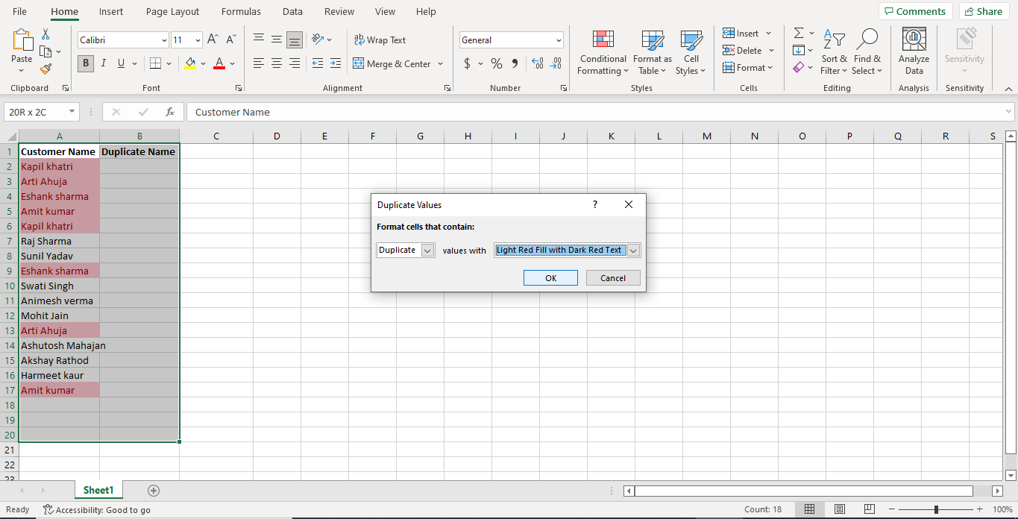

**STEP 3:**

Go to filter option or use shotcut key (CTRL + SHIFT+L) and then filter by fill colour or no fill choose one

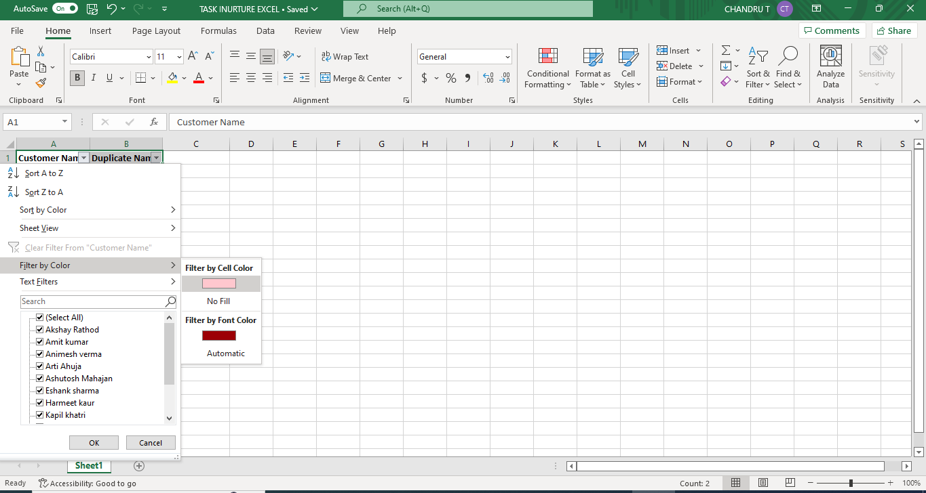

**STEP 4:**

And then use copy paste formulae (= cell name (A2 ))and drag the down cell paste after remove the filter or use shotcut key (CTRL + SHIFT+L) again ,

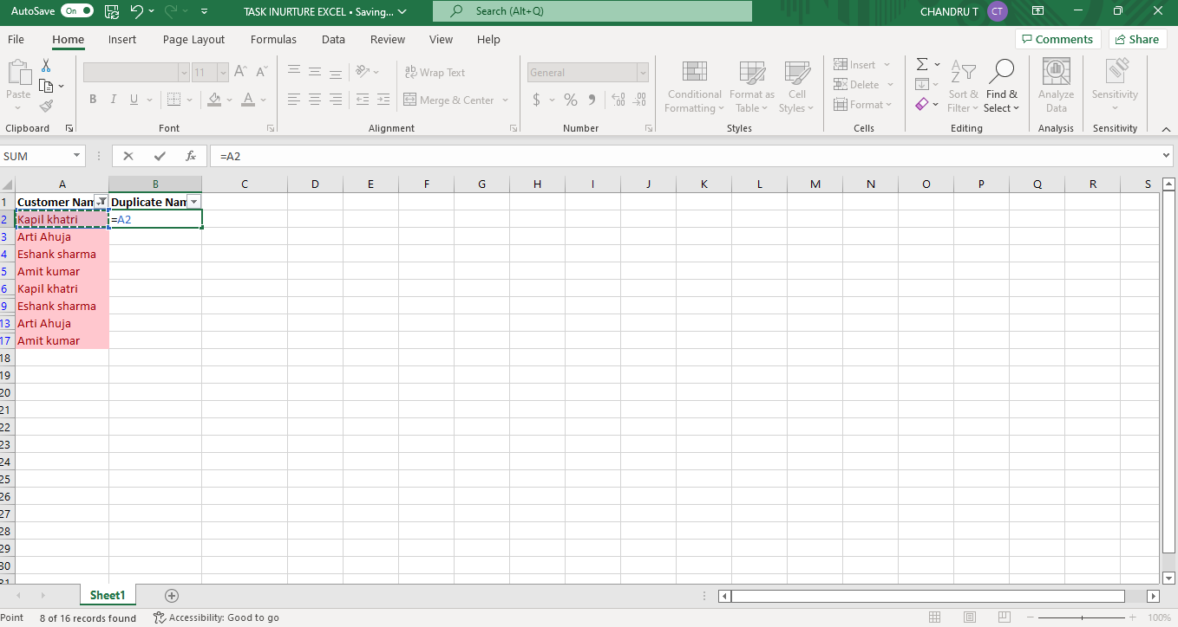

**STEP 5:**

Again go to conditional formatting and then choose clear rule the remove highlights colour and then clear rules from selected cells

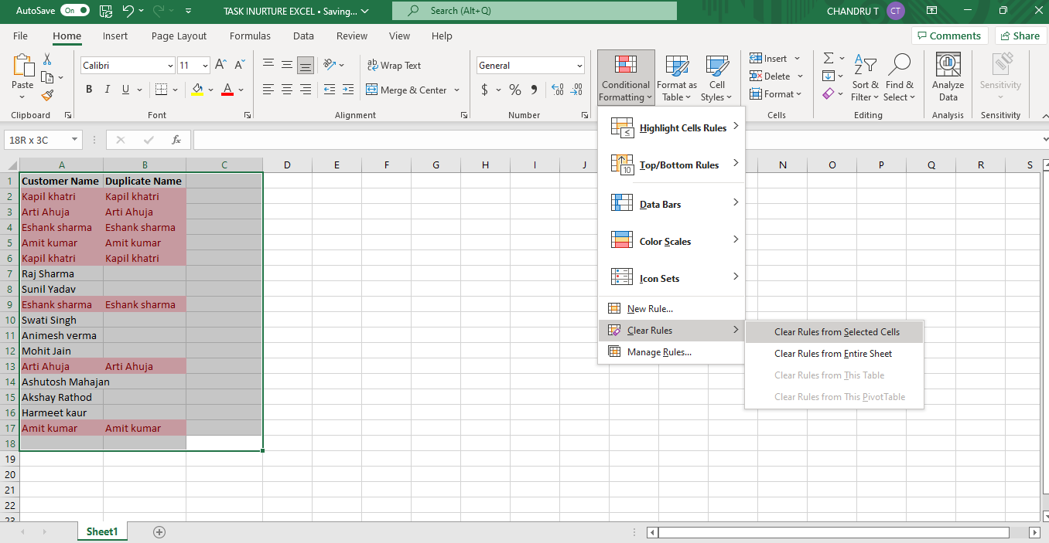

**STEP 6:**

Final outputs see the below images .

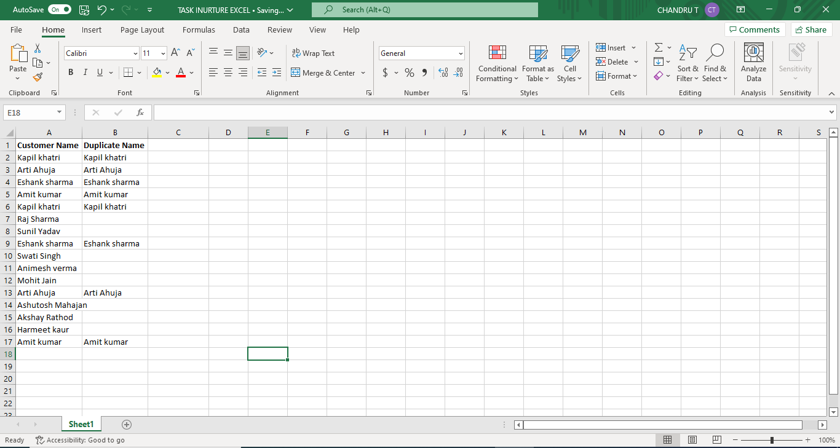

**Topic: Machine Learning**

Description You need to classify fetal health to avoid the abnormalities for the child and mother while giving birth. You will be provided with a CSV consisting of 22 columns out of which the first 21 columns are the factors based on which you need to classify the fetal health which is the last column.

You need to classify the health status into the following:

1.0 - Normal

2.0 - Suspect

3.0 – Pathological